**Python RegEx**

A Regular Expression or **RegEx** is a special sequence of characters that uses a search pattern to find a string or set of strings.

It can detect the presence or absence of a text by matching it with a particular pattern and also can split a pattern into one or more sub-patterns.

**Regex Module in Python**

Python has a built-in module named **“re**” that is used for regular expressions in Python. We can import this module by using the import statement.

A **RegEx,** or Regular Expression, is a sequence of characters that forms a search pattern.

**RegEx** can be used to check if a string contains the specified search pattern.

**RegEx Module**

Python has a built-in package called re, which can be used to work with Regular Expressions.

**Import the re module:**

**import re**

**RegEx in Python**

When you have imported the re module, you can start using regular expressions:

**Example**

Search the string to see if it starts with "**The**" and ends with "**Spain**":

import re

#Check if the string starts with "The" and ends with "Spain":

txt = "The rain in Spain"

x = re.search("^The.*Spain$", txt)

if x:

print("YES! We have a match!")

else:

print("No match")

**RegEx Functions**

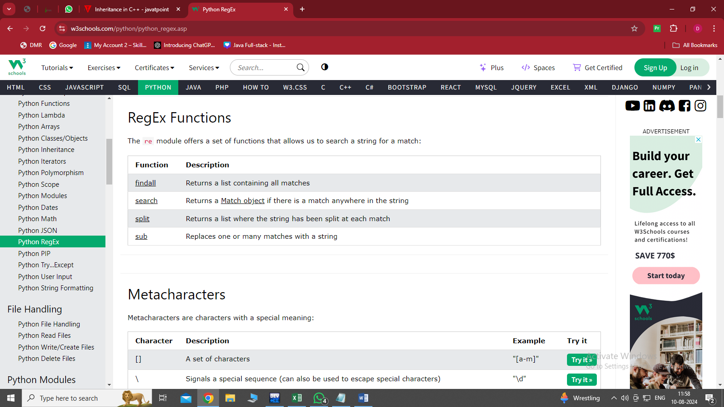The re module offers a set of functions that allows us to search a string for a match:

**The findall() Function**

The **findall()** function returns a list containing all matches.

**Example**

Print a list of all matches:

**import re**

#Return a list containing every occurrence of "ai":

txt = "The rain in Spain"

x = re.findall("ai", txt)

print(x)

The list contains the matches in the order they are found.

If no matches are found, an empty list is returned:

**Example**

Return an empty list if no match was found:

import re

txt = "The rain in Spain"

#Check if "Portugal" is in the string:

x = re.findall("Portugal", txt)

print(x)

if (x):

print("Yes, there is at least one match!")

else:

print("No match")

**The search() Function**

The **search()** function searches the string for a match, and returns a Match object if there is a match.

If there is more than one match, only the first occurrence of the match will be returned:

***Example***

Search for the first white-space character in the string:

import re

txt = "The rain in Spain"

x = re.search("\s", txt)

print("The first white-space character is located in position:", x.start())

If no matches are found, the value **None** is returned:

import re

txt = "The rain in Spain"

x = re.search("Portugal", txt)

print(x)

**The search() Function**

The **search()** function searches the string for a match, and returns a Match object if there is a match.

If there is more than one match, only the first occurrence of the match will be returned:

**Example**

Search for the first white-space character in the string:

import re

txt = "The rain in Spain"

x = re.search("\s", txt)

print("The first white-space character is located in position:", x.start())

If no matches are found, the value **None** is returned:

import re

txt = "The rain in Spain"

x = re.search("Portugal", txt)

print(x)

**The split() Function**

The **split()** function returns a list where the string has been split at each match:

**Example**

Split at each white-space character:

import re

#Split the string at every white-space character:

txt = "The rain in Spain"

x = re.split("\s", txt)

print(x)

You can control the number of occurrences by specifying the **maxsplit** parameter:

**Example**

Split the string only at the first occurrence:

import re

#Split the string at the first white-space character:

txt = "The rain in Spain"

x = re.split("\s", txt, 1)

print(x)

**The sub() Function**

The **sub()** function replaces the matches with the text of your choice:

**Example**

Replace every white-space character with the number 9:

import re

#Replace all white-space characters with the digit "9":

txt = "The rain in Spain"

x = re.sub("\s", "9", txt)

print(x)

You can control the number of replacements by specifying the count parameter:

**Example**

Replace the first 2 occurrences:

import re

#Replace the first two occurrences of a white-space character with the digit 9:

txt = "The rain in Spain"

x = re.sub("\s", "9", txt, 2)

print(x)

**Match Object**

A Match Object is an object containing information about the search and the result.

**Note: If there is no match, the value None will be returned, instead of the Match Object.**

**Example**:

Do a search that will return a Match Object:

import re

#The search() function returns a Match object:

txt = "The rain in Spain"

x = re.search("ai", txt)

print(x)

**The Match object has properties and methods used to retrieve information about the search, and the result:**

**.span()** returns a tuple containing the start-, and end positions of the match.

.**string** returns the string passed into the function

**.group()** returns the part of the string where there was a match

**Example**

Print the position (start- and end-position) of the first match occurrence.

The regular expression looks for any words that starts with an upper case "S":

import re

#Search for an upper case "S" character in the beginning of a word, and print its position:

txt = "The rain in Spain"

x = re.search(r"\bS\w+", txt)

print(x.span())

**Example**

Print the string passed into the function:

import re

#The string property returns the search string:

txt = "The rain in Spain"

x = re.search(r"\bS\w+", txt)

print(x.string)

**Example**

Print the part of the string where there was a match.

The regular expression looks for any words that starts with an upper case "S":

import re

#Search for an upper case "S" character in the beginning of a word, and print the word:

txt = "The rain in Spain"

x = re.search(r"\bS\w+", txt)

print(x.group())

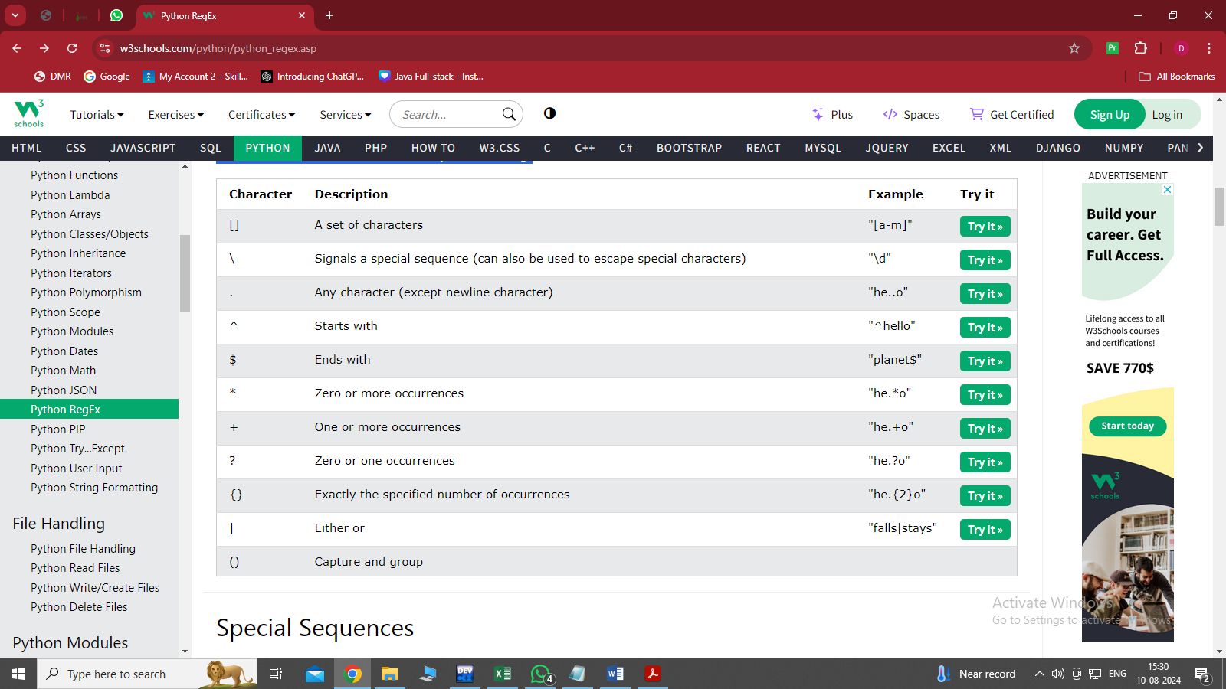**Metacharacters**

Metacharacters are characters with a special meaning:

**1 [] : SET OF CHARACTERS**

import re

txt = "The rain in Spain"

#Find all lower case characters alphabetically between "a" and "m":

x = re.findall("[a-m]", txt)

print(x)

**2 \ :  
 Signals a special sequence (can also be used to escape special characters)**

import re

txt = "That will be 59 dollars"

#Find all digit characters:

x = re.findall("\d", txt)

print(x)

**3 . : Any character (except newline character)**

import re

txt = "hello planet"

#Search for a sequence that starts with "he", followed by two (any) characters, and an "o":

x = re.findall("he..o", txt)

print(x)

**4 ^ : Starts with**

import re

txt = "hello planet"

#Check if the string starts with 'hello':

x = re.findall("^hello", txt)

if x:

print("Yes, the string starts with 'hello'")

else:

print("No match")

**5 $ : Ends with**

import re

txt = "hello planet"

#Check if the string ends with 'planet':

x = re.findall("planet$", txt)

if x:

print("Yes, the string ends with 'planet'")

else:

print("No match")

**6 * : Zero or more occurrences**

import re

txt = "hello planet"

#Search for a sequence that starts with "he", followed by 0 or more (any) characters, and an "o":

x = re.findall("he.*o", txt)

print(x)

**7 + : One or more occurrences**

import re

txt = "hello planet"

#Search for a sequence that starts with "he", followed by 1 or more (any) characters, and an "o":

x = re.findall("he.+o", txt)

print(x)

**8 {} : Exactly the specified number of occurrences**

import re

txt = "hello planet"

#Search for a sequence that starts with "he", followed excactly 2 (any) characters, and an "o":

x = re.findall("he.{2}o", txt)

print(x)

**9 | : Either or**

import re

txt = "The rain in Spain falls mainly in the plain!"

#Check if the string contains either "falls" or "stays":

x = re.findall("falls|stays", txt)

print(x)

if x:

print("Yes, there is at least one match!")

else:

print("No match")

**Special Sequences**

A special sequence is a \ followed by one of the characters in the list below, and has a special meaning:

1. **\A : Returns a match if the specified characters are at the beginning of the string**

import re

txt = "The rain in Spain"

#Check if the string starts with "The":

x = re.findall("\AThe", txt)

print(x)

if x:

print("Yes, there is a match!")

else:

print("No match")

1. **\b: Returns a match where the specified characters are at the beginning or at the end of a word**

import re

txt = "The rain in Spain"

#Check if "ain" is present at the beginning of a WORD:

x = re.findall(r"\bain", txt)

print(x)

if x:

print("Yes, there is at least one match!")

else:

print("No match")

**(the "r" in the beginning is making sure that the string is being treated as a "raw string")**

import re

txt = "The rain in Spain"

#Check if "ain" is present at the end of a WORD:

x = re.findall(r"ain\b", txt)

print(x)

if x:

print("Yes, there is at least one match!")

else:

print("No match")

**3.\B:Returns a match where the specified characters are present, but NOT at the beginning (or at the end) of a word**

import re

txt = "The rain in Spain"

#Check if "ain" is present, but NOT at the beginning of a word:

x = re.findall(r"\Bain", txt)

print(x)

if x:

print("Yes, there is at least one match!")

else:

print("No match")

**(the "r" in the beginning is making sure that the string is being treated as a "raw string")**

import re

txt = "The rain in Spain"

#Check if "ain" is present, but NOT at the end of a word:

x = re.findall(r"ain\B", txt)

print(x)

if x:

print("Yes, there is at least one match!")

else:

print("No match")

1. **\d :Returns a match where the string contains digits (numbers from 0-9)**

import re

txt = "The rain in Spain"

#Check if the string contains any digits (numbers from 0-9):

x = re.findall("\d", txt)

print(x)

if x:

print("Yes, there is at least one match!")

else:

print("No match")

1. **\D : Returns a match where the string DOES NOT contain digits**

import re

txt = "The rain in Spain"

#Return a match at every no-digit character:

x = re.findall("\D", txt)

print(x)

if x:

print("Yes, there is at least one match!")

else:

print("No match")